**Physics Year 11 - Waves Evaluation and Analysis Task**

By Ajay Bisnath

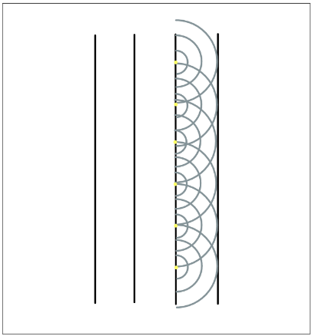Reflection and Refraction with reference to Huygens principle

Huygens Principle states that all points of an advancing wavefront are a new centre of disturbance from which emanate independent waves in all directions. These spherical wavelets cancel each other out to form a straight wavefront. The wavefront is formed by the tangent of all the wavelets (see fig 1.).

Reflection is when a wave bounces against the border between two mediums and some energy remains in the original medium, reflecting and changing direction. The Law of Reflection states that the angle of reflection (α) is equal to the angle of incidence ($θ$). The angle of incidence is the angle between the incident ray and the normal (see fig 2.).

Fig 1. Huygens Principle

Fig 2. The Law of Reflection

The Law of Reflection is explained by Huygens principle. Different parts of the wavefront reflect at different times. The tangent of the wavelets forms the new reflected wavefront (see fig 3.).

Fig 3. Huygens Principle and Reflection

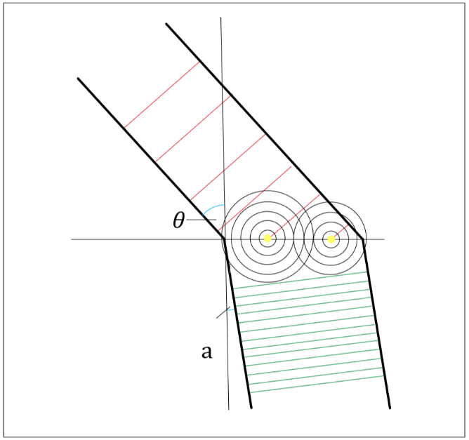

Refraction is when a wave changes direction as it enters a new medium. The waves’ wavelength changes but the frequency remains the same. The wave bends towards the normal when entering a slower medium and vice-versa.

Refraction can be seen by mapping out the centre of disturbances (which have radii equal to the wavelength) of the points of the wavefront that intersect with the boundary between mediums. The tangent of the wavelets gives the new wavefront. Wavelength increases when velocity decreases (see fig 4.), in which the wave will bend towards the normal and vice-versa.

Fig 4. Huygens Principle and Refraction

Snell’s Law of Refraction and Critical Angle

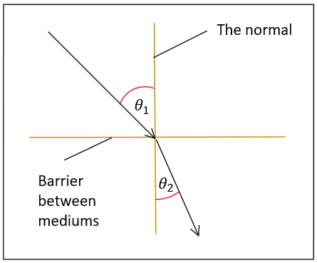Snell’s Law of Refraction states during refraction the refractive index of the initial medium multiplied by the sine of the angle of incidence equals the refractive index of the second medium multiplied by the sine of the angle of refraction. This is represented by:



$n_{1}sin\left(θ_{1}\right)= n_{2}sin\left(θ_{2}\right)∴ n_{21} = \frac{sin⁡(θ_{1})}{sin⁡(θ_{2})}= \frac{n_{2}}{n_{1}}= \frac{λ_{1}}{λ_{2}}= \frac{v_{1}}{v_{2}}$

Where $θ_{1}$ is the angle of incidence and $θ_{2}$ is the angle of refraction (see fig 5.), v1 is the incidence velocity and v2 is the refraction velocity, n1 is the 1st medium's refractive index and n2 is the 2nd medium's refractive index and n21 represents the refractive index of medium 2 with respect to medium 1. Snell’s Law allows us to calculate the angle of refraction when given the angle of incidence and the refractive index of both mediums.

Fig 5. Refraction

The critical angle is the angle of incidence when the angle of refraction is ninety degrees, thus the wave does not enter the second medium and instead runs parallel to the border between the two mediums (see fig 6.). Critical angle can also be defined as the largest incident angle possible if refraction occurs. It only occurs when the first medium is slower than the second medium (denser to rarer). The equation for the critical angle is given from Snell’s Law, $θ=\sin^{-1}\left(\frac{n_{2}}{n_{1}}\right)$ where n1 > n2.

Fig 6. Refraction where angle of refraction is 90◦ $θ$ is the critical angle

If the refractive index of the second medium was greater than the refractive index of the first medium, there would be no solutions for theta and therefore refraction cannot occur.

Ultrasound Imaging

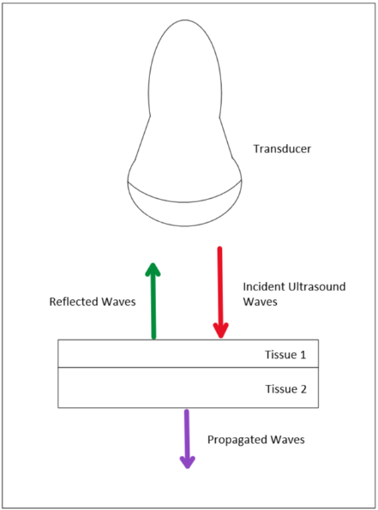Ultrasound Imaging is a form of medical imaging where high-frequency sound waves are reflected against the body and then recorded to image the body allowing viewing inside the body. Ultrasound waves are very high-frequency sound waves. Unlike x-rays, ultrasound waves do not harm the body as they are simply high-frequency sound waves. They are outside the audible range and thus don't cause discomfort for the patient. We use ultrasound imaging because it is safe and produces a good resolution due to ultrasound waves not diffracting heavily.

Ultrasound waves do not diffract heavily because diffraction is more severe when the wavelength of the wave is greater than the dimensions of the obstacle. Shorter wavelength ultrasound is used and thus diffraction only causes resolution to be about half a wavelength which is very good. The shorter the wavelength of the ultrasound wave, the greater the resolution but the less it penetrates the body.

Ultrasound waves make an image of a person's internal body structure and are commonly used to view developing fetus, a person’s abdominal and pelvic organs, muscles and tendons, or their heart and blood vessels. Reflection is a key part of ultrasound imaging. The reason ultrasound imaging works is because most of the ultrasound waves that are directed at the body are reflected back at the transducer which are then recorded. Reflection occurs at tissue boundaries where the tissues on either side of the boundaries have differences in acoustic impedance, which is how much resistance an ultrasound beam encounters as it passes through a tissue (see fig 7.). It is important that the angle of incidence is as close to zero as possible (transducer is perpendicular with tissue) as otherwise some ultrasound waves won’t go directly back to the transducer resulting in a worse image.

Fig 7. Reflection at tissue boundary

If ultrasound waves hit tissue at an oblique angle, refraction will occur. Refracted waves are lost, travelling in a direction away from the transducer, and cause a decrease in the resolution of the final image as only the reflected waves are used for ultrasound imaging.

The procedure for ultrasound begins with gel being applied to the area being scanned. A handheld transducer connected to a monitor directs ultrasound waves at the internal body structure being examined. The reflected sound waves are recorded by the scanner and converted to electrical impulses to create an image that can be seen on the monitor. The distance each ultrasound wave travelled is calculated by the scanner and is used to create the image. The image is in grayscale where denser objects appear brighter than rarer objects.

Bibliography

* Physics Stack Exchange. (2018.). optics - Huygens’ Principle During Reflection: comparing wavelets from before reflection with wavelets from during reflection. [online] Available at: <https://physics.stackexchange.com/questions/161409/huygens-principle-during-reflection-comparing-wavelets-from-before-reflection>.
* www.youtube.com. (2020.). Diffraction and Huygens’s Principle - IB Physics. [online] Available at: <https://www.youtube.com/watch?v=he8jSyRWvxE&ab_channel=AndyMasley%27sIBPhysicsLectures>.
* Physics LibreTexts. (2016). 1.7: Huygens’s Principle. [online] Available at: [https://phys.libretexts.org/Bookshelves/University_Physics/1.07:_Huygenss_Principle](https://phys.libretexts.org/Bookshelves/University_Physics/Book:_University_Physics_%28OpenStax%29/University_Physics_III_-_Optics_and_Modern_Physics_%28OpenStax%29/01:_The_Nature_of_Light/1.07:_Huygenss_Principle).
* Physics LibreTexts. (2016). 25.3: The Law of Refraction. [online] Available at: <https://phys.libretexts.org/Bookshelves/College_Physics/Book:_College_Physics_1e_(OpenStax)/25:_Geometric_Optics/25.03:_The_Law_of_Refraction>.
* brilliant.org. (n.d.). Snell’s Law | Brilliant Math & Science Wiki. [online] Available at: <https://brilliant.org/wiki/snells-law/>.
* The Physics Classroom (2019). The Critical Angle. [online] Physicsclassroom.com. Available at: <https://www.physicsclassroom.com/class/refrn/Lesson-3/The-Critical-Angle>.
* Health, C. for D. and R. (2019). Ultrasound Imaging. FDA. [online] Available at: <https://www.fda.gov/radiation-emitting-products/medical-imaging/ultrasound-imaging#:~:text=Ultrasound%20imaging%20(sonography)%20uses%20high>.
* Better Health Channel (2012). Ultrasound scan. [online] Vic.gov.au. Available at: <https://www.betterhealth.vic.gov.au/health/conditionsandtreatments/ultrasound-scan>.
* Australia, H. (2022). Ultrasound. [online] www.healthdirect.gov.au. Available at: <https://www.healthdirect.gov.au/ultrasound#:~:text=An%20ultrasound%20scan%20is%20performed>.
* Themes, U.F.O. (2017). Physics of Ultrasound. [online] Radiology Key. Available at: <https://radiologykey.com/physics-of-ultrasound-2/>.
* Narwhal Tutoring - <https://narwhaltutoring.org/>